Analysis of Intrinsic Meaning in Director Yeon Sang-Ho’s Animation Works

Ting Wu*, Chul-Young Choi**, Mijin Kim**

Department of Visual Contents, Division of Digital Contents
Graduate School of Dongseo University*, Zhongnan University of Economics and Law*, Dongseo University**
Busan, South Korea
wuting19881210@gmail.com, freechoi@dongseo.ac.kr, mjkim@dongseo.ac.kr

Abstract

Yeon Sang-ho, who is drawing a public attention to his great hit movie ‘Train to Busan’ (2016) that had attracted more than 10 million viewers, was known as independent animation director. Acknowledged for his works that deal with social criticism and man’s hypocrisy, Director Yeon Sang-ho is being highly acclaimed for ‘Train to Busan’, which is a creative Korean version of zombie movie. The great commercial success of the movie is attributed to his creative view of the world and notion of man’s hypocrisy, which mingle well with the object of horror -zombie- and the atmosphere of the current society. The present study is aimed to analyze his animation works and movies directed along with those of other directors who started with an independent movie and attained commercial success, and their unique inner world.

Keywords-Independent movie director Yeon Sang-ho; Post-modernism movie, Commercial movie, Genre movie, Korean version of zombie

I. The Characteristics of Independent Movie Directors

Through unique and creative techniques in works, many independent movie directors have set their own view of the world and tried to explain intrinsic meanings and convinced the audience of them, using abstract visual expressions such as change, transformation, and symbolism of time and space. One common point found among such directors as David Lynch, Coen Brothers, Quentin Tarantino, Zack Snyder, and Bong Jun-ho is that they are widely acknowledged for their independent movies in movie circle and have also achieved success as commercial movie director [1].
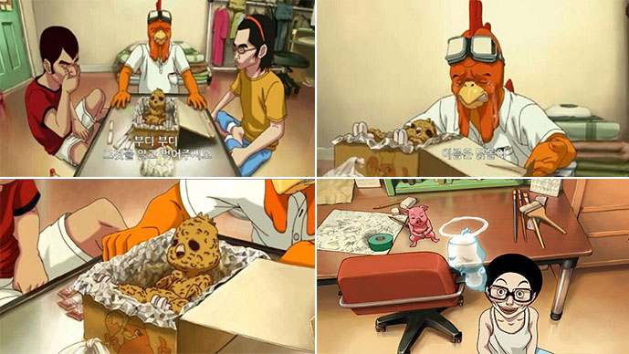
Fig. 1 Scenes from ‘Love Is Protein’

Director Yeon Sang-ho, who became known as animation director with his animation work ‘The King of Pigs’ in Pusan International Film Festival (the PIFF) in 2011 as the movie was put on screen, attracted more than 10 million viewers to his movie ‘Train To Busan’ in 2016, making himself a promising movie director [2]. His works before the great success are characterized with low budget independent animation of ambiguous storytelling, which reflects his strong social consciousness. Looking into the world of his works, this study attempts to explore this rare case that an independent animation director turns into a real-action movie director and made a commercial success from previously noncommercial work.
Director Yeon Sang-ho liked black cartoon series and horror works from his childhood and expressed his propensity of distrust and criticism toward the society through his works. His previous works were all 2D animations and the pictures were drawn in simple and plain style. Also, he tried to highlight and criticize Korean reality in the form of animation.
The themes of social criticism are reflected on his animation works ‘Love Is Protein’ (2008), ‘The King of Pigs’ (2011), ‘The Fake’ (2013), and the latest ‘Seoul Station’ (2016)’. He used post-modernistic and surrealistic expression techniques to beautify violence, and ironic technique to show hierarchical society and extract the inner emotions of a character.

II. Human Basic Instincts revealed in Horror Films

Director Yeon Sang-ho created a unique world for adults in his animation by placing all of selfish, lonely, and helpless emotions of a dark society into an animation work [3].
“Man’s hypocrisy” is the most important theme for his expression and considered as the most unique and profound artistic esthetics. In Fig. 1 ‘Love is Protein’, the scene where the owner of a chicken shop gives his baby to a customer for food, crying, shocked the audience a lot. On one hand, this crying scene makes them feel sorry, but on the other hand this strange scenario that ‘the customer enjoys eating the baby, seeing it off’ satirizes the reality of the hypocritical society.
Fig. 2 animation ‘The Fake’ is a work of lampooning the hypocrisy of a church. It urges many viewers to think over their stereotype of a church and religion and evidences another indirect influence that animations can have.

For this reason, Fig. 3 ‘The King of Pigs’ was invited to and screened in 2011 Pusan International Film Festival (the PIFF). This animation movie surrealistically depicts high school students growing in crisis and in the middle of violent environment. The overall atmosphere of the movie is dark and reality and unreality, and present and past cross over each other. Also in this work, the director criticizes the society for miserable lives of high school students. Using unique camera techniques, the director tried to boldly describe the situations and used close-ups to convey complicated emotions of characters to the viewers.
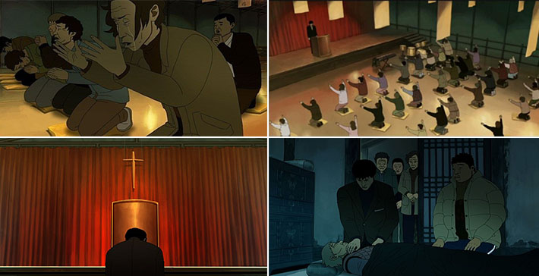
Fig. 2 Scenes from ‘The Fake’
This animation movie is highly evaluated and regarded as one of the rarest excellent works of Korean adult animations that deal with brutal and realistic theme. Director Yeon Sang-ho compares man with pig and personifies cat in order to disclose human inner world more.
Animation movie ‘Seoul Station’ and a live-action movie ‘Train to Busan’ (Fig. 4), which were produced in 2016, also deeply investigate into human basic instincts [4]. They show characters revealing their selfishness when faced with danger without fail and hurt others by any means necessary to save their own lives. It also shows the cruelty of the reality by depicting the government scarify innocent lives for the sake of its benefit. In movie ‘Train to Busan’, the director views the zombies from a different angle and then they feel to us as another reality in the society. Therefore, Director Yeon Sang-ho is regarded as the founder of “Korean version of zombie” and draw a keen interest and attention from the world for his unique personality and style in movie [5].
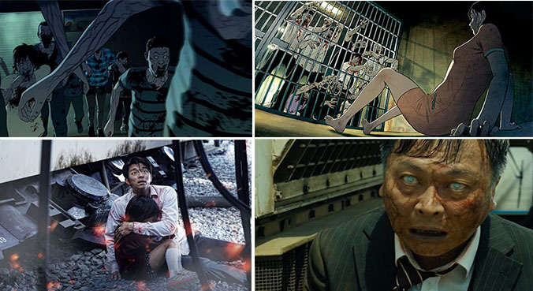
Fig. 4 Scenes from Animation ‘Seoul Station’ and Movie ‘Train to Busan’

III. Conclusion

Zombie movie ‘Train to Busan’, which reflects the director’s view of the world, is drawing an attention, making a commercial hit. While the audience predicates that the expressions of social criticism as shown in his past animation ‘The King of Pigs’ are typical for independent movie, they acknowledge the movie ‘Train to Busan’ for the pleasure of criticism and strong commercialism in which realism with actual images is well blended in Yeon Sang-ho’s way of expressing hypocrisy. As a result, the movie succeeded in attracting more than 10 million viewers to theaters.
This study tried to search directors who had a similar success as Director Yeon Sang-ho’s and analyze their world of work to find factors with which independent movie and commercial movie keep each other’s boundary and can make a success. As webtoons has recently become very popular in Korea, they are often reborn to movie before animation. Korean cartoons and animations are more easily converted to movie than other countries because they are realistic and reflect social aspects rather than pursue fantasy movie. In a following study, the author intends to examine the contents of originals for movie and the intent of expression of the originals and movie directors.
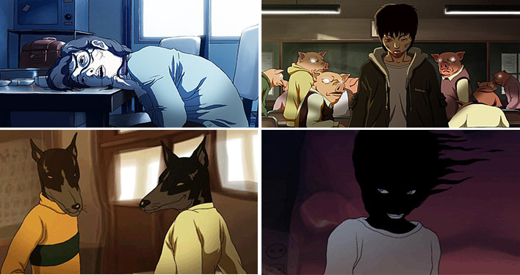
Fig. 3 Scenes from ‘The King of Pigs’

References

[1] T. Lee, “The analysis of the irony technique for black comedy genre Film - With the Cohen brother’s recent films,” Korea: Journal of Digital Design, Vol. 1, pp.603-615, 2014.
[2] S. Kukan, “Role of Experimental Animation for the Development and Diversification of Korean Animation Industry,” Korea: Journal of Digital Design, Vol. 5, pp.142-161, 2015.
[3] J. Hong, “A Narrative Formation That Changed Audience’s Perception - The Fake directed by Sang-ho, Yeon,” Cine forum, Vol. 22, pp.163-190, 2015.12.
[4] C. Dong, “A Study on the Support Policy for Low-budget Feature Animated Film,” The Korean Journal of animation, Vol. 4, pp.78-94, 2012.12.
[5] K. Mun, “A Study on self-reflexive aesthetics and a play strategy which appears in Korean independent film- Yoon sung ho and GogSa,” film Sstudies, Vol. 54, 2012.12.

